|  |  |  |  |
| --- | --- | --- | --- |
| D:\Rinat\Rinat\доки\журнал\статьи\logo.jpg | HYBRID COMPOSITES BASED ON CHITOSAN MODIFIED BY CONJUGATES OF Ag AND Cu NANOPARTICLES WITH DIHYDROQUERCETIN | | |
| Cite this: *INEOS OPEN*,  **2025**, *8 (1–3)*, 112–113  DOI: 10.32931/io2542a  *Received 1 November 2024,*  *Accepted 16 January 2025*  http://ineosopen.org | | P. R. Voloshina,\**a,b* А. N. Tretyakova,*a,c* А. S. Golub,*a* and А. Yu. Vasil'kov*a* | |
| *a Nesmeyanov Institute of Organoelement Compounds, Russian Academy of Sciences, ul. Vavilova 28, str. 1, Moscow, 119334 Russia*  *b* Mendeleev University of Chemical Technology of Russia, Miusskaya pl. 9, Moscow, 125047 Russia  c *Moscow Institute of Physics and Technology (National Research University), Institutskiy per. 9, Dolgoprudny, Moscow Region, 141700 Russia* | |
| Abstract  New hybrid materials based on chitosan modified with conjugates of metal nanoparticles (silver and copper) and dihydroquercetin, a biologically active flavonoid with antioxidant and anti-inflammatory properties, were obtained. The metal nanoparticles were prepared by the environmentally safe metal-vapor synthesis. The resulting materials exhibit biological activity against bacteria *Bacillus cereus* and *Escherichia coli*. | | | abstract1 |
| **Key words:** chitosan, copper and silver nanoparticles, dihydroquercetin, biological activity, metal-vapor synthesis. | | | |

**Introduction**

The creation of new metal-containing materials based on biopolymers for medical applications is one of the most relevant and intensively developing areas. The interest to this field is caused by an increase in the number of microorganism strains resistant to most antibiotics. It was established that biologically active nanoparticles of metals and their oxides do not cause resistance in microorganisms. The introduction of metal nanoparticles into the biopolymer structure can ensure an increase in the antimicrobial activity and impart new functional properties to the resulting composite. Owing to their biological and physicochemical properties, the materials based on natural polymers (chitosan, cellulose, *etc.*), flavonoids and metal nanoparticles can meet the basic requirements for medical materials [1]. Chitosan (Chit) is a polyaminosaccharide derived from crustacean shell chitin. Owing to the presence of amino and hydroxy groups, this polymer possesses chelating properties and can stabilize metal nanoparticles [2, 3]. A significant number of studies demonstrated the high biological activity of silver and copper nanoparticles (NPs), which stimulates their use in the creation of new functional materials [4, 5]. Dihydroquercetin (DHQ) is a flavonoid with high antioxidant, capillary-protective and anti-inflammatory activity [6]. Flavonoids can regulate the immune response, reduce inflammation, and prevent angiogenesis. It can be expected that the materials obtained on the basis of a combination of quercetin, metal nanoparticles, and chitosan will promote activation of regenerative processes in damaged tissues and increase the antimicrobial and antibacterial activity of the system as a whole. Herein, we report on the synthesis of new Ag- and Cu-containing hybrid materials based on chitosan modified by dihydroquercetin conjugates with silver or copper nanoparticles, which were obtained by the environmentally safe method of metal-vapor synthesis.

Results and discussion

The properties of materials containing metal nanoparticles are determined not only by the composition, particle sizes, and nature of the specific interaction with the matrix stabilizing them, but also by the method of obtaining the material. Metal-vapor synthesis (MVS) is effective for the synthesis of metal nanoparticles and allows one to avoid or significantly reduce contamination introduced into biomedical materials [7–11]. Using the MVS method, the materials based on chitosan modified by dihydroquercetin conjugates with silver (AgNP@DHQ) and copper (CuNP@DHQ) nanoparticles were obtained. The resulting materials were characterized using scanning electron microscopy (SEM) and powder X-ray diffraction (PXRD).

The method of obtaining the composite is shown in Scheme 1. An organosol containing Ag or Cu NPs and DHQ in isopropanol or toluene was used to modify chitosan. The analysis of the surface of the AgNPs–Chit composite by SEM revealed minor morphological changes in the structure of the material compared to the original Chit (see Fig. S1 in the Electronic supplementary information (ESI)).

Transmission electron microscopy was used to study the microstructure of metal nanoparticles obtained by MVS. As can be seen from the micrographs (Fig. S2 in the ESI), Cu and Ag

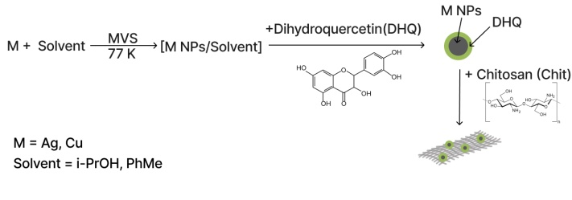

Scheme 1. Production of a chitosan-based composite modified by dihydroquercetin conjugate with silver or copper nanoparticles.

NPs are present in these products with particle sizes of 3 nm and 6 nm, respectively.

The diffraction patterns of the initial chitosan and products of its modification with metal nanoparticles are shown in Fig. 1. In addition to the broad asymmetric reflections at 2θ ~10.5° and ~20° characteristic of chitosan, the patterns of silver-containing composites exhibit reflections in the region 2θ > 35°. The positions of these reflections correspond to the phase of metallic silver (sp. gr. Fm-3m, *a* = 4.0862 Å): 38.11° (111), 44.3° (002), 64.44° (022), 77.4° (311), 81.54° (222). The Rietveld refinement of the diffraction profile in the specified region using the Ag metal phase allows for a sufficiently reliable description of the diffraction data, the divergence factor (*R*wp) being 1.6% and 3.4% in the case of Chit-AgNPs@DHQ and Chit-AgNPs, respectively. The evaluation of the crystallite sizes (*D*) of the Ag phase by the broadening of the diffraction reflections using the Scherrer method showed that this phase is significantly more dispersed in the Chit-AgNPs@DHQ composite (*D* = 9 nm) than in Chit-AgNPs (*D* = 24 nm).

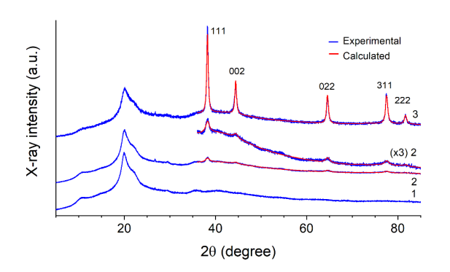

**Figure 1**. Experimental (blue) and calculated (red) powder diffraction patterns of initial chitosan (**1**), Chit-AgNPs@DHQ (**2**), and Chit-AgNPs (**3**). The reflection indices of the silver metal phase are indicated.

In the case of the Chit-CuNPs composite, the diffraction patterns of the initial and modified chitosan do not differ markedly from each other (see Fig. S3 in the ESI), which indicates an amorphous nature of the copper-containing compounds in this material.

The bacteriostaticactivity of DHQ, AgNPs and AgNP@DHQ was studied against gram-positive (*Bacillus cereus*) and gram-negative (*Escherichia coli*) bacteria (Table 1).

**Table 1.** Minimum inhibitory concentrations of the samples explored

|  |  |  |
| --- | --- | --- |
| Sample | *B. cereus* | *E. coli* |
| AgNPs | 10 mg/mL | 10 mg/mL |
| DHQ | 0.156 mg/mL | 1.25 mg/mL |
| AgNP@DHQ | 0.16 mg/mL | 0.625 mg/mL |

The results obtained suggest that AgNP@DHQ nanoparticles exert stronger inhibitory effects than AgNPs.

**Conclusions**

New biologically active hybrid materials based on chitosan modified by conjugates of metal silver or copper nanoparticles with dihydroquercetin were obtained by the metal-vapor synthesis using *i*PrOH and toluene as the reaction medium. Their compositions, surface, and antibacterial properties were investigated. The results obtained can be used in the creation of medical materials.

Acknowledgements

This work was supported by the Russian Science Foundation (project no. 24-23-00220). The authors are grateful to T. Batsalova for the biological studies. The work was performed using the equipment of the Center for Collective Use of INEOS RAS.

Corresponding author

* E-mail: voloshina-pr@yandex.ru (P. R. Voloshina).

Electronic supplementary information

Electronic supplementary information (ESI), available online: the materials and methods, SEM and TEM images, XRD patterns. For ESI, see DOI: 10.32931/io2542a.

References

1. P. Senthilkumar, G. Yaswant, S. Kavitha, E. Chandramohan, G. Kowsalya, R. Vijay, B. Sudhagar, D. S. Ranjith Santhosh Kumar, *Int. J. Biol. Macromol*., **2019**, *141*, 290–298. DOI: 10.1016/j.ijbiomac.2019.08.234

2. H. Huang, X. Yang, *Biomacromolecules*, **2004**, *5*, 2340–2346. DOI: 10.1021/bm0497116

3. G. Di Carlo, A. Curulli, R. G. Toro, C. Bianchini, T. De Caro, G. Padeletti, D. Zane, G. M. Ingo, *Langmuir*, **2012**, *28*, 5471–5479. DOI: 10.1021/la204924d

4. A. Raghunath, E. Perumal, *Int. J. Antimicrob. Agents*,**2017**, *49*, 137–152. DOI: 10.1016/j.ijantimicag.2016.11.011

5. P. Rousselle, M. Montmasson, C. Garnier, *Matrix Biol*.,**2019**, *75–76*, 12–26. DOI: 10.1016/j.matbio.2018.01.002

6. S. V. Orlova, V. V. Tatarinov, E. A. Nikitina, A. V. Sheremeta, V. A. Ivlev, V. G. Vasil'ev, K. V. Paliy, S. V. Goryainov, *Pharm. Chem. J*.,**202*2***, *55*, 1133–1137. DOI: 10.1007/s11094-022-02548-8

7. A. Vasil'kov, N. Tseomashko, A. Tretyakova, A. Abidova, I. Butenko, A. Pereyaslavtsev, N. Arkharova, V. Volkov, E. Shtykova, *Coatings*, **2023**, *13*, 1315. DOI: 10.3390/coatings13081315

8. G. Cárdenas-Triviño, M. J. Saludes-Betanzo, L. Vergara-González, *Int. J. Polym. Sci*.,**2020**, *2020*, 5920941. DOI: 10.1155/2020/5920941

9. M. S. Rubina, E. E. Said-Galiev, A. V. Naumkin, A. V. Shulenina, O. A. Belyakova, A. Yu. Vasil'kov, *Polym. Eng. Sci.*, **2019**, *59*, 2479–2487. DOI: 10.1002/pen.25122

10. A. N. Tretyakova, A. Yu. Vasil'kov, *INEOS OPEN*, **2023**, *6*, 49–54. DOI: 10.32931/io2312a

11. G. Cárdenas-Triviño, I. Monsalve-Arellano, M. Nuñez-Decap, *J. Chil. Chem. Soc*.,**2022**, *67*, 5503–5513. DOI: 10.4067/S0717-97072022000205503

|  |  |
| --- | --- |
| This article is licensed under a Creative Commons Attribution-NonCommercial 4.0 International License. | [D:\Rinat\Rinat\доки\журнал\cc-by-nc.png](https://creativecommons.org/licenses/by/4.0/) |